Assignment: Human

A) Human Processor Model (4 points)

A1) Reaction Time-Experiment – Visual Stimulus
In this task, you should conduct a small experiment to determine the reaction times to detect a color change in a stimulus. You can use the simple HTML program provided for this task:
After you click the “Start Experiment” button, the blue circle in the center of the screen will randomly turn orange within 2 to 5 seconds. Press the space bar as soon as possible after the circle has changed its color to orange. The reaction time is displayed in milliseconds after each trial. Once the experiment is finished after 10 trials, the reaction times will be exported in a .CSV-file.

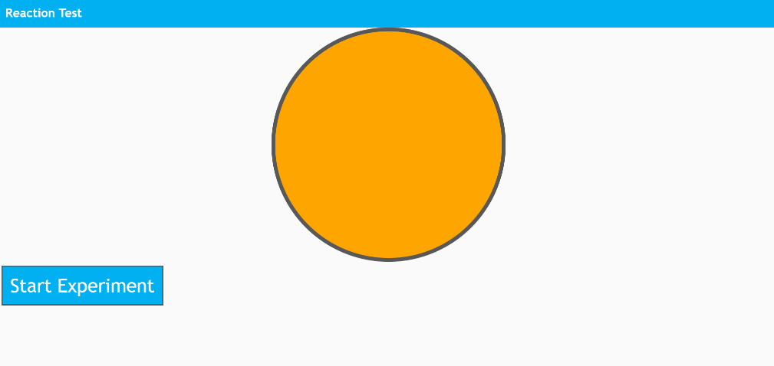
Fig. 1: Screenshot of the application that detects reaction times to changes in visual stimuli
Carry out the experiment with at least four participants and document the reaction times. You can also carry out the experiment four times with yourself due to the current corona situation. Calculate the mean for your participants (or yourself) and plot them side by side in a bar chart. Have a look at this tutorial https://www.youtube.com/watch?v=rf_Wmr3JqDo or the following screenshot to see how to make plots in Excel.
Fig.2: Screenshot of how to make a plot in Excel

A2) Reaction Time-Experiment – Auditive Stimulus
In this task, you should conduct a similar experiment with an acoustic signal. We also provide a simple HTML application for this task that works in the same way. Follow the procedure of task A and conduct a second experiment with the same number of participants (or yourself) and trials. Plot the means for this task, as well.
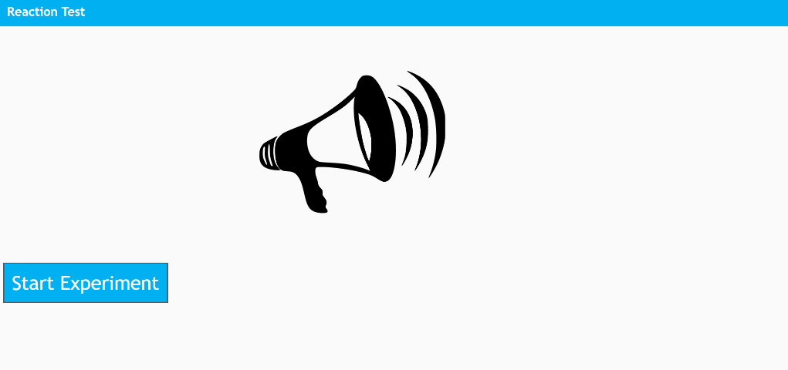
Fig. 3: 2 Screenshot of the application that detects reaction times to changes in auditive stimuli

A3) Model-based Calculation of the Results

Calculate the reaction times for A1 and A2 based on the Human Processor Model.

A4) Discussion Based on the Human Processor Model
Are your results in line with the results of the Human Processor Model? Discuss the results of both experiments A1 and A2. How do the results differ and why? (150 to 250 words).

B) Information Processing and Perception (2 points)

B1) Spectrum of Vision

What spectrum of light can people see? Which sensory cells are responsible for this?

B2) Depth Perception
What depth cues can you see in the following picture that allow you to perceive depth? Specify and describe (in one to two sentences) five depth cues based on the picture.
Fig. 4: Image Source https://www.flickr.com/photos/pjgardner/178553427 by Jessica Gardner

B3) Hearing

Describe the three mechanisms that allow us to hear spatially (50 to 100 words).

C) Learning (2 points)

C1) Conditioning
Describe learning by conditioning (50 words).

C2) Application
Imagine an application that could facilitate learning through conditioning and describe it (50 words).

D) Gestalt Laws (2 points)

D1) Gestalt Principles
Name the Gestalt Laws or Principles.

D2) Application

Graphically sketch an application or input device that uses at least four Gestalt laws. Describe how the laws are applied (50-150 words).

E) Emotions (2 points)

E1) Basic Emotions
Name the six basic emotions.

E2) Character Design
Imagine that you have to create two characters for a game, one is happy and one is sad. For both characters, describe facial expressions, posture and their way of speaking according to Scott Brave and Clifford Nass (2002). (150 to 200 words).

References
Brave, Scott & Nass, Clifford. (2002). Emotion in Human–Computer Interaction. The Human-Computer Interaction Handbook: Fundamentals, Evolving Technologies and Emerging Applications. 10.1201/b10368-6.

Submission:
Hand in the following files:
- A PDF with the results of task A, B, C, D, E.
- The two csv-files with the results of task A1 and A2
Upload your submission files by 27 May 2020, 23:59 packed in a compressed ZIP folder. Name your ZIP folder as follows:
Example: Assignment_Human_HCI_SS20_Maxi_Mustermann.zip

Have Fun!

