Assignment: Introduction to Human-Computer Interaction

A) Task-Artifact Cycle (2 points)

A.1) Sketch the Task-Artifact Cycle
Sketch the Task-Artifact Cycle as introduced by J. Carrol. Based on the concept, describe how user needs and technologies are evolving together (50 to 100 words).

A.2) Autonomous Driving: Task-Artifact Cycle
Consider the example of autonomous driving in the context of the Task-Artifact Cycle. Discuss, based on the following quote, what needs are articulated and how this impacts the artifacts design. Speculate how this will provide new possibilities and what further human needs may develop (100 to 200 words).
“Human activities implicitly articulate needs, preferences and design visions. Artifacts are designed in response, but inevitably do more than merely respond. Through the course of their adoption and appropriation, new designs provide new possibilities for action and interaction. Ultimately, this activity articulates further human needs, preferences, and design visions.”
Carroll, John M. (2013): Human Computer Interaction - brief intro. In: Soegaard, Mads and Dam, Rikke Friis (eds.). "The Encyclopedia of Human-Computer Interaction, 2nd Ed.". Aarhus, Denmark: The Interaction Design Foundation. Available online at http://www.interaction-design.org/encyclopedia/human_computer_interaction_hci.html

B) Maslow’s Hierarchy of Needs (2 points)
The motivation theory of Maslow was already published in 1943. Since then psychologists have extended Maslow’s theory [1] and have proposed new concepts [2].
The following two blog-posts discuss in short some of the criticism and new ideas:
- https://www.psychologytoday.com/sg/blog/sex-murder-and-the-meaning-life/201005/rebuilding-maslow-s-pyramid-evolutionary-foundation
- https://www.psychologytoday.com/sg/blog/sex-murder-and-the-meaning-life/201706/do-you-have-be-self-centered-be-self-actualized
Discuss in your own words some of the shortcomings of Maslow’s theory and describe the changes that are propose for the pyramid (100-200 words).

References:
[1] Kenrick, D. T., Griskevicius, V., Neuberg, S. L., & Schaller, M. (2010). Renovating the pyramid of needs: Contemporary extensions built upon ancient foundations. Perspectives on psychological science, 5(3), 292-314.
[2] Krems, J. A., Kenrick, D. T., & Neel, R. (2017). Individual perceptions of self-actualization: What functional motives are linked to fulfilling one’s full potential?. Personality and Social Psychology Bulletin, 43(9), 1337-1352.

C) Usability and User Experience (2 points)

C.1) Usability according Jakob Nielsen
How did Nielsen define Usability? What are the five components he associates with usability?

C.2) Trade-Offs in Usability
Make a concrete example that highlights the trade-off in usability between learnability and efficiency. Sketch at least 2 alternative user interfaces for an application of your choice, where one focuses on efficiency and one on learnability. Explain your sketches and the trade-offs. Which further trade-offs do you expect (50-100 words).

C.3) Timing and User Experience
How does timing affect the user experience? Read the blog post “Powers of 10: Time Scales in User Experience” and give a short summary (50-100 words).
- https://www.nngroup.com/articles/powers-of-10-time-scales-in-ux/

D) Affordance (2 points)

D.1) Affordance and Perceived Affordance according to Don Norman.
Explain in your own word the concept of perceived affordance as introduced by Norman. Give specific examples from everyday live that shows how the affordance increase the human ability to quickly understand how to use things (50-100 words)

D.2) Affordance – Create Examples
Take photos or short video of at least 10 different door handles and doors that you encounter in your daily live. Discuss the design of the door handles, how easy they are to use, and explain how this relates to the concept of affordance. Create a short video (max 120 seconds) in which you show the door handles and where you add your discussion as audio track (alternatively you can write it up – about 200-400 words, 10 photos).
If you cannot physically go and take photos, use photos from the web that are under a creative commons license (please make sure you are allowed to use them, add attribution where required).
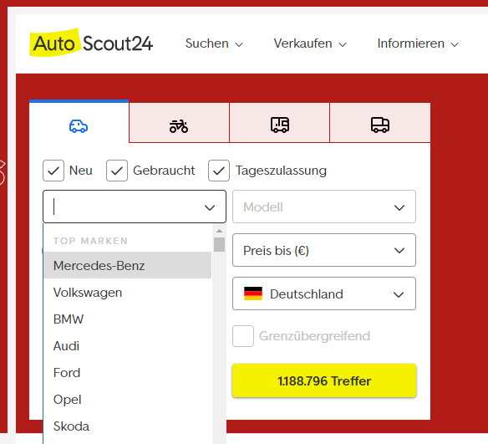
Figure 1: screenshot of a menue from Autoscout24.de

E) Improving Menus (1 point)

E.1) Font Menus
Discuss shortly how font menus have improved over time. What features where added and how did these features increase usability. (20-50 words)

E.2) Sketch an Improvement
In figure 1, a screenshot from the website autoscout24.de is shown. This includes a menu for selecting the make of the car. Make a sketch of a new menu, that improves this menu analog to the example of the font menu discussed in the lecture.

Submission:
Hand in the following files:
- A PDF with your solution for each task (A,B,C,D)
- Your optional video (D2)
Upload your submission files by 10 May 2020, 23:59 packed in a compressed ZIP folder. Name your ZIP folder as follows:
Example: Assignment_1_HCI_SS20_Max_Mustermann.zip

Have Fun!

