Assignment: Input Devices, Transfer Functions

A) Understanding Input Devices (4 points)

A.1) Input Devices - a Definition
How does Bill Buxton describe what an input device is? Provide his definition and explain it in your own words (50 to 100 words).

A.2) A Taxonomy
What dimensions does Bill Buxton suggest in his taxonomy? How does this relate to the classification based on the physical properties suggested by Card et al. 1991? (50 to 100 words).

A.3) Devices
Draw and briefly describe (50 to 100 words per devices) how the following devices are classified. You can use the uploaded table and draw the physical properties (e.g. shapes and lines in word).
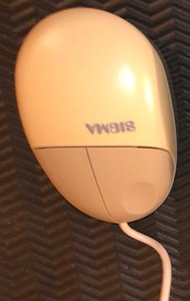
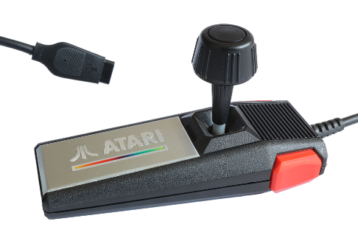

A.4) Formal description
Fundamentally, there are two variants of joysticks: the digital one and the analog one. They are differentiated by how they measure the input. A digital joystick has only switches (typically four, one on each side) and can measure if the stick is moved towards a certain direction. By moving the stick one or two switches are pressed. For an analog joystick, the angle of the position of the stick or the force is measured.
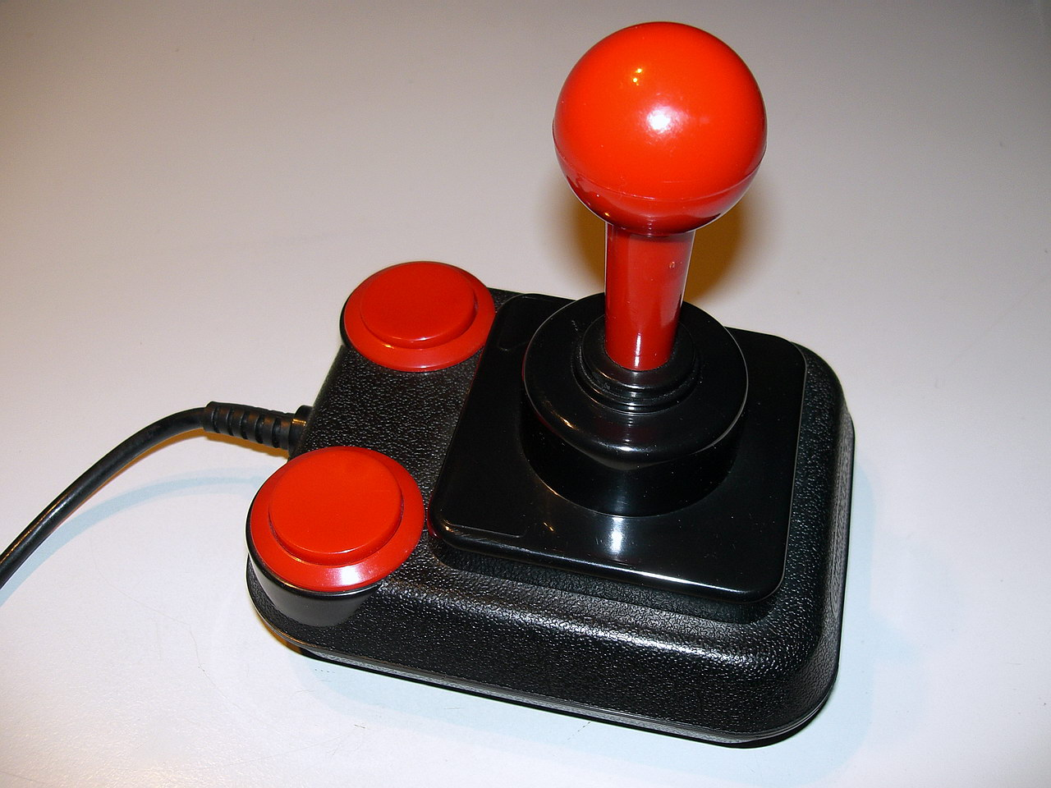
„Es gibt zwei grundlegende Varianten von Joysticks, zum einen in digitaler und zum anderen in analoger Ausführung. Zur Unterscheidung muss hier die Art der Betätigung herangezogen werden. Als digital gilt der Joystick, der nur Schaltkontakte mit An- und Aus-Signal verarbeitet. Als analog betrachtet man auch einen Joystick […], der […] eine Auswertung der Betätigungskraft bzw. des Auslenkungswinkels vornimmt.“ https://de.m.wikipedia.org/wiki/Joystick

How do you describe a joystick in the six-tuple notation?
(M, In, S, R, Out, W)
Choose one of the two joystick technologies and describe it in the six-tuple notation. Briefly explain (two to three sentences) the choice you made (especially what technology you expect is included in the joystick, e.g. if analog or digital data acquisition).

A.5) Clutch for Input Devices
Explain the term clutch for input devices in your own words and give an example for a clutch mechanism for 2DOF (100 to 200 words).

A.6) Controller Resistance
Explain the basic properties of the following three types of controller resistance and find examples of devices that fall into this category (50 to 100 words per property):
- Isometric (infinite resistance)
- Isotonic (free moving)
- Elastic

A.7) Rate vs. Position Control
Explain in your own words what rate and position control for input devices is (100 to 200 words). Are the following examples rate or position control? Explain your answers in one sentence each.
- Pressing the arrow key on the keyboard to move the cursor on the screen
- A gaming steering wheel to steer a car in a game
For what type of controller resistance is it better to use position control? Explain your answer (20 to 50 words).

B) Transfer Function (4 points)

B.1) Concept
Explain what a transfer function is (100 to 200 words).

B.2) Understanding
There is an implementation of different transfer functions (function 1, function 2, function 3) given.
You can see the prototype here https://hci-lecture.org/HCI/topics/iotech/transferfunc01.html.
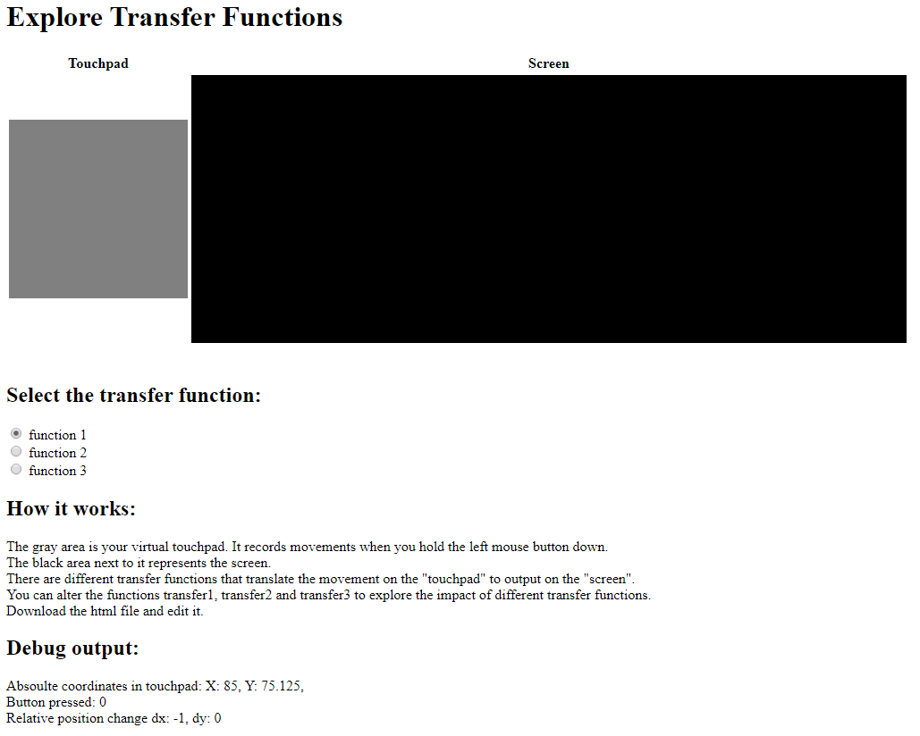
Download the HTML prototype and explore the functions, look at the source code (JavaScript, at the upper part of the file within the <script> - tag) and explain what each transfer function does (25 to 50 words per transfer function).

B.3) New Transfer Functions
Change the implementation of the transfer functions in JavaScript (function 1, function 2, and function 3) in the HTML – prototype. You can find the description for the implementation as comments in the HTML file.
Afterward, provide examples for devices with the following transfer functions:
- A function that does an absolute mapping from the whole touchpad to the whole screen
- A function that provides a relative mapping with the cursor wrapping around (e.g. when it hits the top border it comes in at the bottom)
- A function where x and y of input and output are exchanged

B.4) Dynamic Transfer Functions
Assume you a have screen where you need very precise pointing at the left top corner and only very coarse pointing at the right and bottom of the screen. The grid in the figure below shows the assumed size of the buttons in these areas.
How could you design a transfer function to support this - high precision in one area and fast movement in the other?
Design a function that receives the following variables as input:
- dx and dy (the change of the mouse position since last time)
- currentScreenX and currentScreenY (the current position of the cursor in the screen)
And provides as output
- screenX and screenY (the new positions x and y on the screen)
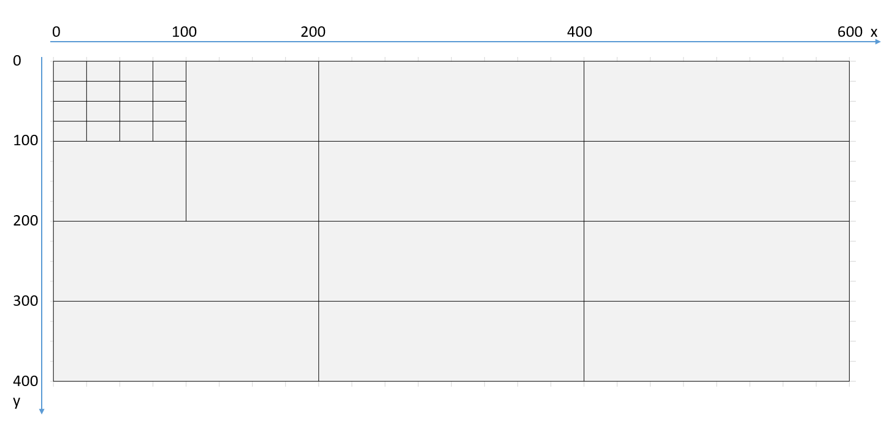
You can describe your function as text and explain your idea (150 to 250 words) or optionally you can also modify one of the provided transfer functions in the HTML prototype.

Submission:
Hand in the following files:
- A PDF with your solution for each task (A,B)
- A HTML file with the solution to B.3 and optionally a HTML file with the solution to B.4
Upload your submission files by <date> 2020, 23:59 packed in a compressed ZIP folder. Name your ZIP folder as follows:
Example: Assignment_IOTech_HCI_SS20_Max_Mustermann.zip

Have Fun!

