Assignment: Models in HCI

A) Fitts’ Law (4 points)

A.1) Determine input device-dependent constants
Paul Fitts conducted several studies to verify the model he had created [1]. In one of his experiments, participants had to transfer plastic washers from one pin to another. To investigate the average time of movement (MT), he systematically varied the distance between the pins (distance) and the diameter of the pins (width). Consider the four widths and distances and the corresponding MT in the table below. Calculate the input device-dependent constants based on the values shown in the table and specify the outcome to three decimals. Make a scatter plot, fit a line and specify the linear equation according to the procedure in the lecture “Basics of Fitts Law”. You can have a look at this tutorial https://www.dummies.com/software/microsoft-office/excel/how-to-create-a-scatter-plot-in-excel/ how to make a scatter plot and how to determine the linear equation.
width | distance | MT
0,0625 | 4 | 0,697
0,0625 | 8 | 0,771
0,0625 | 16 | 0,896
0,0625 | 32 | 1,096
0,125 | 4 | 0,649
0,125 | 8 | 0,734
0,125 | 16 | 0,844
0,125 | 32 | 1,028
0,25 | 4 | 0,607
0,25 | 8 | 0,672
0,25 | 16 | 0,771
0,25 | 32 | 0,975
0,5 | 4 | 0,535
0,5 | 8 | 0,623
0,5 | 16 | 0,724
0,5 | 32 | 0,902

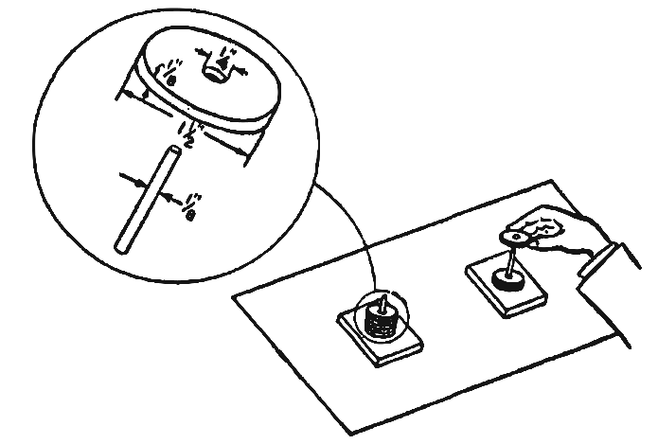

[1]

References
[1] Fitts, P. M. (1992). The information capacity of the human motor system in controlling the amplitude of movement. Journal of Experimental Psychology: General. US: American Psychological Association. https://doi.org/10.1037/0096-3445.121.3.262

A.2) Conduct a small user study
Use the provided HTML apparatus with a one-dimensional Fitts’ Law task that allows you to measure the MT of an input device for four distances and widths. Figure 1 shows the apparatus. Conduct a small user study with four participants (two per input device) or yourself to determine the mean MT of two different input devices (e.g. mouse and touchpad). For each combination of width and distance participants (or yourself) successively complete 8 repetitions resulting in 128 trials (width(4) x distance(4) x repetitions(8)). The first trial starts after triggering the left box. The experiment automatically ends after 128 trials and you can export the data as a csv file. Create a bar plot depicting the mean MT per input device side by side and calculate the throughput for each input device. Briefly interpret the data (100 to 200 words).

Figure 1: Fitts' Law Apparatus consisting of two clickable boxes. The red border around the box indicates the next box to be clicked.

B) KLM Model (3 points)

B.1) Basics and Assumptions
Describe how KLM is used to predict the time a user needs to complete a certain task. What assumptions about user skill and errors are made? (100 to 200 words).

B.2) Operators
What are the most important operators when assessing an application on a classical desktop interface operated with mouse and keyboard? Name the operator and describe it in one sentence

B.3) Application of KLM
In this task you should use KLM to compare different interfaces with regard to their expected task completion time:

B.3.1) Design Three Alternative UIs
You are asked to design a graphical user interface for use on a desktop computer for data entry. The user is expected to enter the following data into the interface:
- name, email address
- year of birth (between 1900 and 2020)
- favorite color
- shoe size (25 to 52, European)
- height (100 to 230, cm)
- weight (40 to 150, kg)
Create three alternative visual designs for the input form. You can use different input widgets, such as text fields, radio buttons, drop-down menus, or sliders. Describe what pressing the tab key and the return key will do in the interface. You can create your design with a visual sketch (hand drawn), with drawing software (e.g. PowerPoint), or using HTML.

B.3.2) Calculate the Task Completion Time
Define a typical user input and calculate for each interface the expected completion time using KLM. Calculate the difference between these interfaces and determine the fastest and slowest one. Briefly discuss the results (50 to 100 words).

C) KLM for Tangible Objects (3 points)

C.1) KLM for Lego
https://pixabay.com/de/photos/legosteine-duplo-lego-bunt-2458575/
Assume you should develop KLM for building Lego structures. You have only one type of stone (2x2) and a base plate. You can place stones on the base plate and you can connect stones to stones that are already fixed on the base plate: (200 to 300 words)
- What operators would you need to define?
- How would you set up an experiment for estimating the associate times for each operator?
- What could you predict with your model?
- For which tasks would you expect your model to be very accurate and for which tasks would you expect less accuracy?
- Would it also work for DUPLO-Stones (big Lego)?
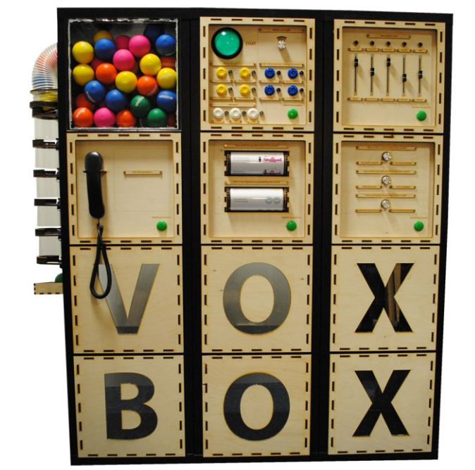

C.2) KLM for Tangible Interaction
The VoxBox is a tangible voting interface. Graphical interface elements are replaced by physical objects such as switches and sliders. Read the referenced paper for further information.
How could you develop a KLM model for such a tangible interface? What operators would be required and how could they be estimated? Is KLM useful in this context? (200 to 300 words)

Paper: Golsteijn, C; Gallacher, S; Koeman, L; Wall, L; Andberg, S; Rogers, Y; Capra, L; (2015) VoxBox: A Tangible Machine that Gathers Opinions from the Public at Events. TEI '15: Proceedings of the Ninth International Conference on Tangible, Embedded, and Embodied Interaction. (pp. pp. 201-208). Association for Computing Machinery (ACM): New York, NY, USA
https://discovery.ucl.ac.uk/id/eprint/1452403/1/tei15.pdf.
Video Presentation at TEI2015: https://www.youtube.com/watch?v=mBIbXWSv4D0

Submission:
Hand in the following files:
- A PDF with the input device-dependent constants, the scatter plot and the linear equation (A.1), the bar plot, the throughput per input device and the interpretation of your study’s results (A.2), and the solution for B and C.
- The four CSV-files (two per input device) with the raw user data of A.2
Upload your submission files by 07 June 2020, 23:59 packed in a compressed ZIP folder. Name your ZIP folder as follows:
Example: Assignment_Models_HCI_SS20_Max_Mustermann.zip

Have Fun!

